Date: 21.03.2026
Getting Started Guide: HANA CV to SQL Converter
This guide will walk you through using our powerful SaaS platform, which converts SAP HANA Calculation Views into optimized SQL code compatible with modern databases like Google BigQuery, Snowflake, Databricks, Redshift, SAP DataSphere and Azure Synapse Analytics

What Our Tool Does
Our platform efficiently converts SAP HANA Calculation Views into highly optimized SQL code. This automated solution handles the entire migration process, including support for PySpark output for Databricks and Microsoft Fabric platforms.
Our platform efficiently converts SAP HANA Calculation Views into highly optimized SQL code. This automates the time-consuming process of manual re-coding, significantly accelerating data migration and cloud adoption projects.
Who Should Use This Tool
This tool is for SAP BW HANA consultants, data engineers, and migration teams who need to transition their data models and business logic from SAP HANA to flexible, scalable SQL-based data warehousing solutions.
Key Benefits
Substantial Time Savings: Automates a traditionally manual process.
Unparalleled Accuracy: Minimizes the need for post-conversion adjustments.
Broad Cross-Platform Compatibility: Supports a wide range of target databases including Snowflake, Google BigQuery, Databricks, Amazon Redshift, Microsoft Fabric, and SAP DataSphere.
PySpark Support: Generate PySpark DataFrame API code as Jupyter notebooks for Databricks and Microsoft Fabric.
Streamlined Workflow: Reduces manual effort and lowers overall project costs.
- Unparalleled Accuracy: Minimizes the need for post-conversion adjustments.
- Broad Cross-Platform Compatibility: Supports Snowflake, Google BigQuery, Databricks (PySpark), Amazon Redshift, Microsoft Fabric (PySpark), and SAP DataSphere.
PySpark Support: Generate PySpark DataFrame API code as Jupyter notebooks for Databricks and Microsoft Fabric.
- Streamlined Workflow: Reduces manual effort and lowers overall project costs.

Accessing the Platform
You can securely access our platform through your web browser at https://hanacv2sql.com. For the best experience, we recommend using the latest version of Google Chrome, Microsoft Edge, or Mozilla Firefox with JavaScript enabled. A minimum screen resolution of 1280x800 pixels is recommended for optimal viewing.

Creating an Account
To get started, click the "Sign Up" button on the homepage. You will be prompted to provide your email address and create a password. You can also sign up or log in using your existing Email account for added convenience. After signing up, you’ll receive an email with a verification link. Be sure to click this link to activate your account and gain full access.

Available Tools and Their Usage
- HANA CV to SQL Converter

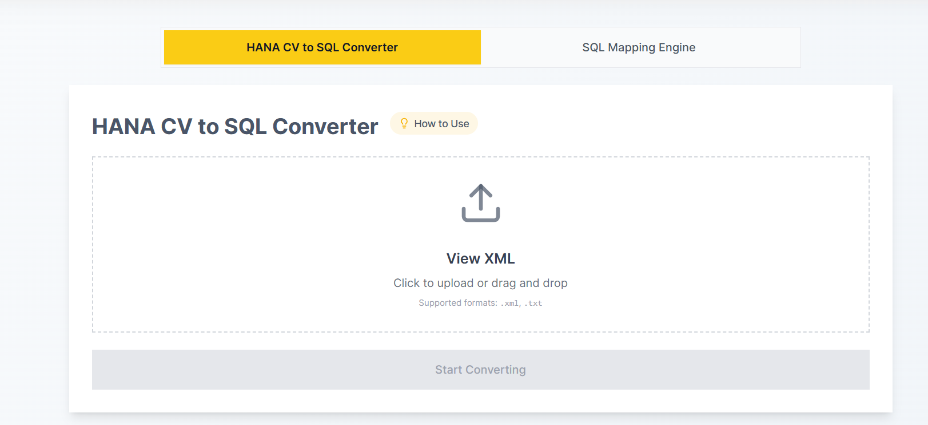
This tool converts the logic from your HANA Calculation Views into standard SQL queries.
- How to Use:
  - Step 1: Get XML File from HANA Studio: To obtain the XML file from HANA Studio, open the relevant view or object. In the toolbar, click on the "XML" icon and select "Display View XML" from the dropdown menu. Save the XML content.
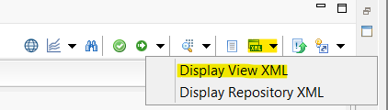
  - Step 2: Upload XML Files: Upload your View XML file. The platform accepts .xml or .txt formats.
  - Step 3: Process Files: Click the "Process" button. The tool validates the file, shows the node count, and identifies if the conversion is paid or free.
  - Step 4: Get Results: Once processed, a ZIP file containing the converted SQL queries and node-level logic is available for download. This file, along with an encrypted Excel sheet for data mapping, is stored on your Account > Conversions page.
- Pro Tips: For best results, validate your XML files before uploading them. You may need to make minor adjustments to the SQL after conversion to ensure it works perfectly in your target system.

Interactive SQL Flow during conversion:
During conversion, the system generates an interactive CTE flow for the SQL query, showing how each CTE is connected to the others. This allows you to easily determine dependencies, which can then be documented for future reference.
Sample:
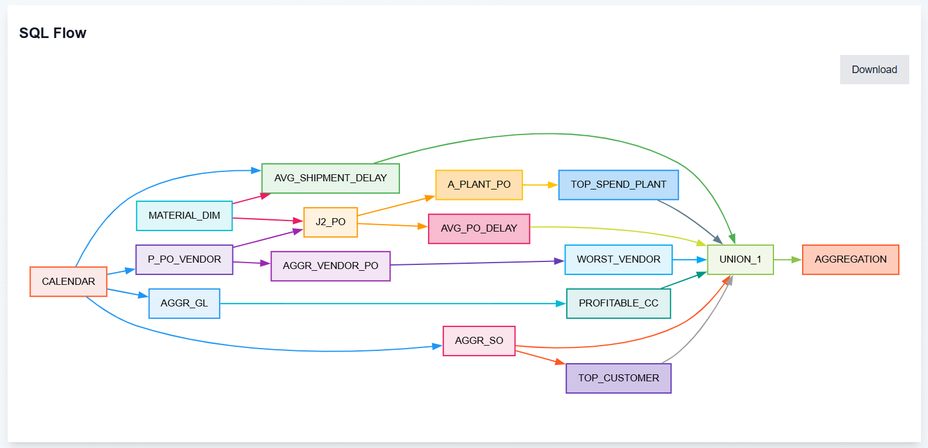

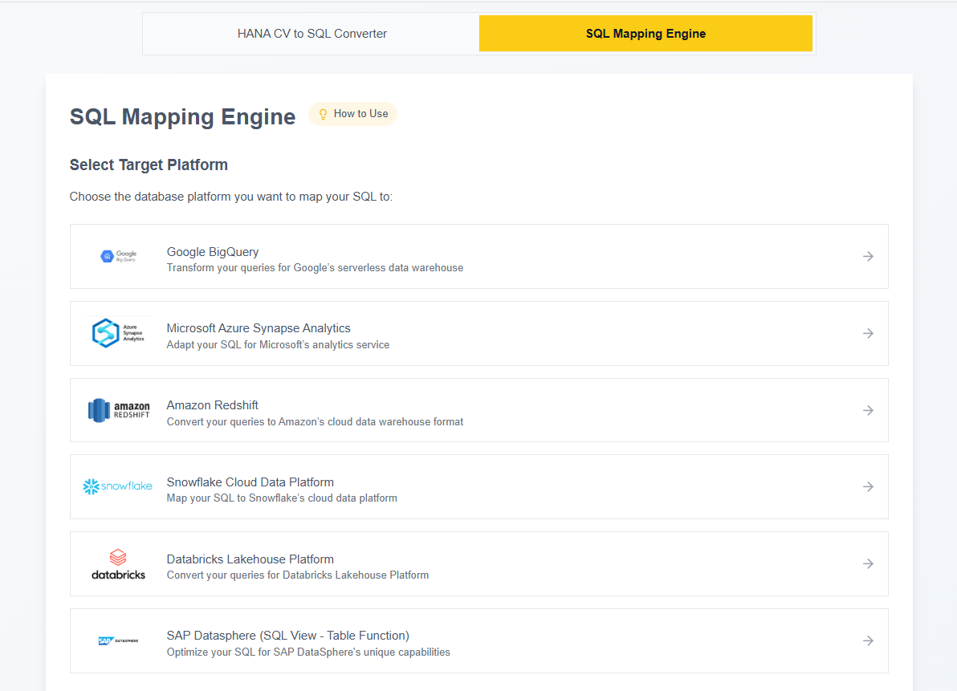
This engine generates SQL based on custom table and column mappings for your target system.

- How to Use:
  - Step 1: Select Target Data Processing System: Choose your desired target system from the provided options:
1. Google BigQuery
2. Azure Synapse Analytics
3. Amazon Redshift
4. Snowflake
5. Databricks (PySpark Available)
6. Microsoft Fabric (PySpark Available)
7. SAP DataSphere

  - Step 2: Upload Your Encrypted XLSX Mapping File: Upload the encrypted Excel mapping file (.xlsx) you received from a previous conversion. You can find this file on the Account > Conversions page.
  - Step 3: Update Custom Mapping and Generate: Update the custom table and column mappings to match your target system, then click "Process" to generate the new SQL.
  - Step 4: Download Generated SQL: Download the generated SQL file containing your transformed queries.
Step 5: Choose Output Format (For Databricks & Microsoft Fabric): When selecting Databricks or Microsoft Fabric as your target, you can choose between SQL or PySpark output. PySpark generates a Jupyter notebook (.ipynb) file with DataFrame API code.
Step 6: Load Previous Mappings: You can load mapping files from your previous conversions directly into the SQL Mapping Engine. Simply select a previous conversion from your history that has an associated mapping file.
Pro Tips: The mapping editor supports bulk paste from Excel, allowing you to quickly populate multiple rows. You can also download your current mapping for future use.

The Account Dashboard provides a comprehensive overview of your activity and settings, organized into several tabs.
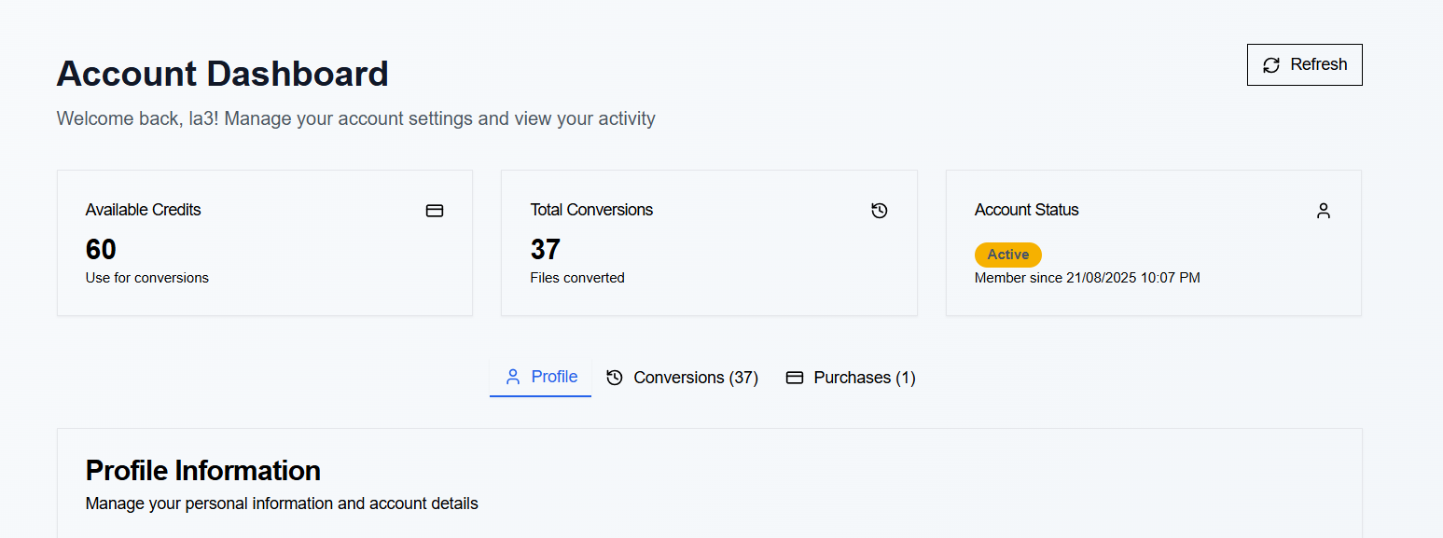
- Quick Stats (Dashboard Overview): Get a snapshot of your account's health. You'll see your Available Credits, the Total Conversions you've performed, and your Account Status along with your membership date.
- Profile Tab: Manage your personal information. This is where you can view your email address, update your display name, and see your current credit balance. You can also securely sign out from this tab.
- Conversions Tab: This tab is your conversion history log. For each conversion, you'll see the file's name, date, node count, and status. You can also download previous conversion results and load mapping files directly into the SQL Mapping Engine.
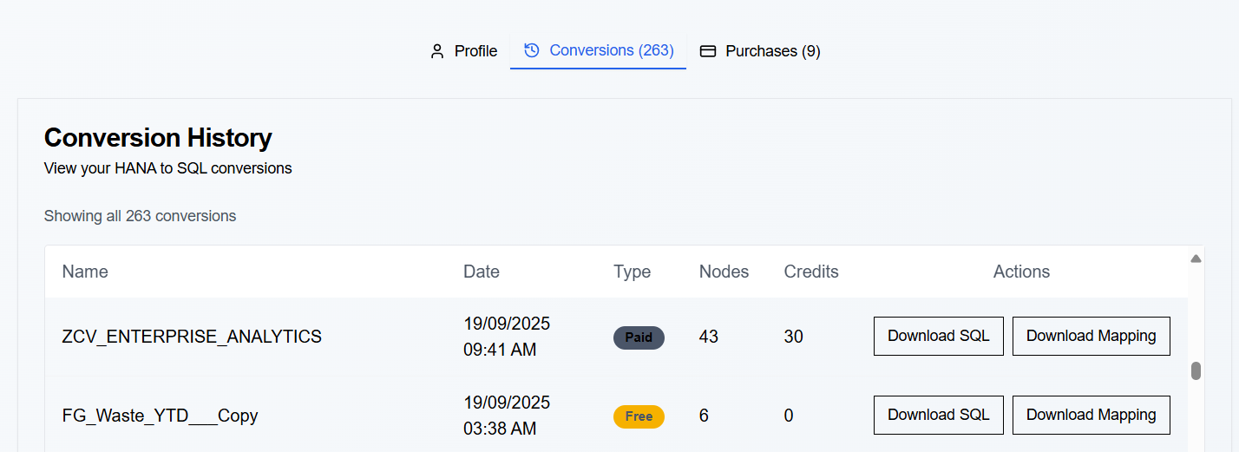

- Purchases Tab: View a detailed history of your credit purchases. Each entry shows the purchase Date, Type, the number of Credits acquired, and the Amount of the transaction.

Free Tier
New users receive 5 free conversions per day for Calculation Views with 1–10 nodes.
Credit System
Our transparent credit system is based on the number of nodes in your HANA Calculation View, where 1 Credit = $1.
- 1–10 Nodes: 10 credits
- 10–20 Nodes: 10 credits
- 20–40 Nodes: 20 credits
- 40+ Nodes: 30 credits
Purchased credits do not expire. You can easily purchase more credits at any time through your profile settings. For Enterprise solutions, contact us for custom pricing.

- Common Login Issues: Solutions for forgotten passwords, account lockouts, or email verification problems.
Conversion Errors: A guide to understanding and resolving common error messages.
Subscription Issues: How to check your credit balance and manage your plan.
PySpark Generation: For Databricks and Microsoft Fabric, you can now generate PySpark code as Jupyter notebooks (.ipynb files) in addition to standard SQL.
Multi-Cloud Support: Our tool supports Snowflake, Google BigQuery, Databricks, Amazon Redshift, Microsoft Fabric, and SAP DataSphere.
Support: For direct assistance, you can reach our support team via email at support@hanacv2sql.com.
- Conversion Errors: A guide to understanding and resolving common error messages.
- Subscription Issues: How to check your credit balance and manage your plan.
- Support: For direct assistance, you can reach our support team via email at support@hanacv2sql.com.

How to Submit Feedback
We value your input. Please use the in-app feedback form or email us at support@hanacv2sql.com to suggest improvements or report issues.

Introduction

Accessing and Setting Up Your Account

Navigating the Dashboard and Available Tools

SQL Mapping Engine

Account Information

Pricing & Subscription

Troubleshooting & FAQ

